Raymond Delgado

February 26, 2021

HWK 3 Normalization

Part 1 Answer the questions.

* 1. What is a relational database?

A relational database is organized to recognized relations among stored items of information. These items are organized into relations. A relation is 2-D table which consist of records (rows) and attribute/field(columns). The different relations are connected using key attributes. The concept of a relational database was first introduced by E.F Codd in 1970s.

* 1. What is referential integrity of the database?

A rule that maintains consistency among the rows of two relations. Foreign key must either be:

* Match a primary key value in another relation.
* Must be null
  1. What is entity integrity?

It is designed to ensure that every relation has a primary key attribute. The value of the primary ey must be unique and not non-null

* 1. How to you map Entities to Tables/Relations?

Mapping regular entities to relations or tables includes the following steps:

* Simple attributes: E-R attributes map directly onto columns in the relation.
* Composite Attributes: Use only their simple, component attributes in relation
  1. How do you map 1:M relationship to RDB?

Create a foreign key in on the many side entity. The foreign key comes from the PK in the parent table. FK and PK must have the same domain.

* 1. How do you map M:N relationship to RDB?

Create a new intersection table. The composite primary key comes from PK in each of its parent table.

* 1. How do you map 1:1 relationship to RDB?

To map a binary 1:1 relationship to RDB, create an FK in the optional side.

* 1. How do you map a Multivalued Attribute to RDB?

Create a separate relation with a foreign key taken from the original superior entity. Or flatten the multi-valued attribute into the original table.

* 1. How do you map Weak Entities to RDB?

Becomes a separate relation with a foreign key taken from the strong/superior entity.

* Primary key composed of: Partial identifier of weak entity and primary key of identifying relation (strong entity)
  1. How do you map Ternary Associative Entities to RDB?

Create a new intersection table. The composite primary key comes from PK in each of its parent tables.

* 1. How do you map Supertype and subtype to RDB?

One table for a supertype and one table for each subtype.

Relationship between supertype and subtype is One: One.

Referential integrity is identifier/subtype disconnector in subtype (foreign key) refers to the primary key in supertype.

* 1. What is normalization? Why do we need normalization?

The process for assigning attributes to entities. It involves identifying the required attributes and their subsequent decomposition into normalized tables based on the functional dependency analysis between the attributes. It also ensures that the data model's relations do not have data redundancy, which can cause update anomalies when implemented.

Why we need normalization:

* Remove anomalies
  1. What is functional dependency?

The relationship (within the relation) that describes how the value of one attribute may be used to find the value of another attribute. Functional dependencies are relationships among the attributes within a relation

* 1. What is partial dependency?

A condition in which an attribute is dependent on only a portion of the primary key.

* 1. What is transitive dependency?

A condition in which an attribute (non-primary-key) is dependent on another attribute (non-primary-key) that is not part of the primary key.

* 1. What is full dependency?

A condition in which an attribute is functionally dependent on a composite key but not on any subset of that composite key.

* 1. What is first NF?

A table is first NF when there are no multivalued attributes, all attributes are dependent or partially dependent on the primary key.

* 1. What is 2nd NF?

The table needs to be in 1 NF i.e., table needs to satisfy 1 NF conditions. 1NF plus every non-key attribute is fully functionally dependent on the ENTIRE primary key.

* Every non-key attribute must be defined by the entire key, not by only part of the key.
* No partial functional dependencies
  1. What is 3rd NF?

The table needs to be in 2 NF. And addition to this remove the transitive dependency. This is called transitive, because the primary key is a determinant for another attribute, which in turn is a determinant for a third

* 1. What is de-normalization? Why do we need de-normalization?

The reverse of normalization. Combining two or more tables into one table. Normalization purity is difficult to reach in the real database environment. The main reason for de-normalization:

* Faster query
* Simpler query.

Part 2 Bottom up database design. Normalize AuthorBook Table (Modified from Question 4-54 in Textbook)

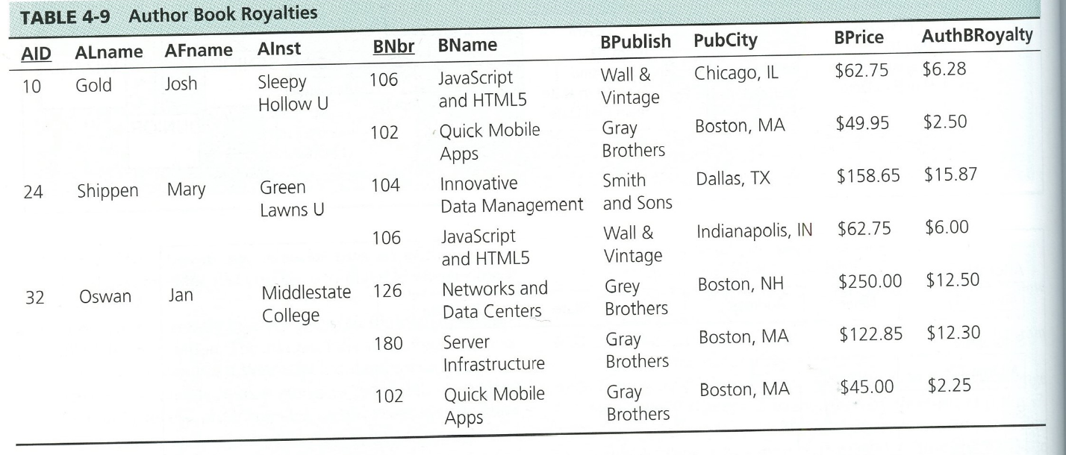

1. What is the current normal form for Table 4-9 Author Book Royalties? Justify your answer.

The table is in unnormalized because it has multivalued attributes. For example, Book name has more than one value which is not automatic.

1. What is the primary key?

The primary keys for the table is author id(AID) and book number(bnr).

1. Move the table into 1NF.

Table: Author Book Royalites

|  |  |  |  |  |  |  |  |  |  |
| --- | --- | --- | --- | --- | --- | --- | --- | --- | --- |
| AID | ALname | AFname | AInst | BNbr | BName | BPublish | PubCity | BPrice | AuthrRolaity |
| 10 | Gold | Josh | Sleep Hollow U | 106 | Java Script & HTML5 | Wall & Vintage | Chicago, IL | $62.75 | $6.28 |
| 10 | Gold | Josh | Sleep Hollow U | 102 | Quick Mobile Apps | Gray Brothers | Boston, MA | $49.95 | $2.50 |
| 24 | Shippen | Mary | Green Lawn U | 104 | Innovative Data Management | Smith & sons | Dallas, TX | $158.65 | $15.87 |
| 24 | Shippen | Mary | Green Lawn U | 106 | Java Script & HTML5 | Wall & Vintage | Chicago, IL | $62.75 | $6 |
| 32 | Oswan | Jan | Midstate College | 126 | Network & Data centers | Grey Brothers | Boston, NH | $250 | $12.50 |
| 32 | Oswan | Jan | Midstate College | 180 | Server Infrastructure | Gray Brothers | Boston MA | $112.85 | $12.30 |
| 32 | Oswan | Jan | Midstate College | 102 | Quick Mobile Apps | Gray Brothers | Boston, MA | $45.00 | $2.25 |

1. Write down functional dependencies including (partial, transitive and full dependencies).

AID 🡪 ALname, AFname, AInst (Partial)

Bnbr 🡪 BName, BPublish, BPrice (Partial)

Bpublish 🡪 PubCity (Transitive)

AID, Bnbr 🡪 AuthorBRoyalty (Full)

1. Move write down the tables into 2NF by removing partial dependency. List all the tables in 2NF.

Tables in 2NF

Table: Author

|  |  |  |  |
| --- | --- | --- | --- |
| AID(PK) | ALname | AFname | AInst |

Table: Book

|  |  |  |  |  |
| --- | --- | --- | --- | --- |
| Bnbr(PK) | BName | BPublish | PubCity | Bprice |

Table: AuthorBookRoyalites

|  |  |  |
| --- | --- | --- |
| AID(PK)(FK01) | Bnbr(PK)(FK02) | AuthrRoyality |

Table: Author

|  |  |  |  |
| --- | --- | --- | --- |
| AID | ALname | AFname | AInst |
| 10 | Gold | Josh | Sleep Hollow U |
| 24 | Shippen | Mary | Green Lawn U |
| 32 | Oswan | Jan | Midstate College |

Table: Book

|  |  |  |  |  |
| --- | --- | --- | --- | --- |
| Bnbr | BName | BPublish | PubCity | BPrice |
| 106 | Java Script & HTML5 | Wall & Vintage | Chicago, IL | $62.75 |
| 102 | Quick Mobile Apps | Gray Brothers | Boston, MA | $49.95 |
| 104 | Innovative Data Management | Smith & sons | Dallas, TX | $158.65 |
| 126 | Network & Data centers | Grey Brothers | Boston, NH | $250 |
| 180 | Server Infrastructure | Gray Brothers | Boston MA | $112.85 |

Table: Author Book Royalties

|  |  |  |
| --- | --- | --- |
| AID | Bnbr | AuthrRoyality |
| 10 | 106 | $6.28 |
| 10 | 102 | $2.50 |
| 24 | 104 | $15.87 |
| 24 | 106 | $6 |
| 32 | 126 | $12.50 |
| 32 | 180 | $12.30 |
| 32 | 102 | $2.25 |

1. Move write down the tables into 3NF by removing transitive dependencies. List all the tables in 3NF.

Tables in 3NF

Table: Author Book Royalties

|  |  |  |
| --- | --- | --- |
| AID(PK)(FK01) | Bnbr(PK)(FK02) | AuthrRoyality |

Table: Author

|  |  |  |  |
| --- | --- | --- | --- |
| AID(PK) | ALname | AFname | AInst |

Table: Publisher

|  |  |
| --- | --- |
| PName(PK) | PubCity |

Table: Book

|  |  |  |  |
| --- | --- | --- | --- |
| Bnbr(PK) | BName | BPrice | BPublish(FK) |

Table: Author Book Royalties

|  |  |  |
| --- | --- | --- |
| AID | Bnbr | AuthrRoyality |
| 10 | 106 | $6.28 |
| 10 | 102 | $2.50 |
| 24 | 104 | $15.87 |
| 24 | 106 | $6 |
| 32 | 126 | $12.50 |
| 32 | 180 | $12.30 |
| 32 | 102 | $2.25 |

Table: Author

|  |  |  |  |
| --- | --- | --- | --- |
| AID | ALname | AFname | AInst |
| 10 | Gold | Josh | Sleep Hollow U |
| 24 | Shippen | Mary | Green Lawn U |
| 32 | Oswan | Jan | Midstate College |

Table: Publisher

|  |  |
| --- | --- |
| PName | PubCity |
| Wall & Vintage | Chicago, IL |
| Gray Brothers | Boston, MA |
| Smith & sons | Dallas, TX |
| Grey Brothers | Boston, NH |
| Gray Brothers | Boston MA |

Table: Book

|  |  |  |  |
| --- | --- | --- | --- |
| Bnbr | BName | BPrice | BPublish |
| 106 | Java Script & HTML5 | $62.75 | Wall & Vintage |
| 102 | Quick Mobile Apps | $49.95 | Gray Brothers |
| 104 | Innovative Data Management | $158.65 | Smith & sons |
| 126 | Network & Data centers | $250 | Grey Brothers |
| 180 | Server Infrastructure | $112.85 | Gray Brothers |

1. Write down referential integrities between all the tables in 3NF.

Table: AuthorBookRoyalites

|  |  |  |
| --- | --- | --- |
| AID(PK)(FK1) | Bnbr(PK)(FK2) | AuthrRoyality |

Table: Author

|  |  |  |  |
| --- | --- | --- | --- |
| AID(PK) | ALname | AFname | AInst |

Table: Publisher

|  |  |
| --- | --- |
| PName(PK) | PubCity |

Table: Book

|  |  |  |  |
| --- | --- | --- | --- |
| Bnbr(PK) | BName | BPrice | BPublish(FK) |

AuthorBookRoyalites.AID 🡪 Author.AID

AuthorBookRoyalites.Bnbr 🡪 Book.Bnbr

Book.BPublish 🡪 Publisher.PName